BAHRIA UNIVERSITY, ISLAMABAD
Department of Computer Science



INTRODUCTION TO DATA SCIENCE LAB

─────────────────────────────

LAB JOURNAL # 05

─────────────────────────────

SUBMITTED BY  Umm-e-Habiba Imran  01-134241-048  6TH A | SUBMITTED TO  Maryam Aslam  Fall 2026  24th September 2026

Visualize the data through all the graphs discussed in class and mentioned in objectives.
Work it by visualizing the at least two different data sets.i.e. train.csv, test.csv etc

Train Dataset
import pandas as pd
import matplotlib.pyplot as plt
import seaborn as sns
# Read Train dataset
df = pd.read_csv("Week5/Train.csv")
# Display first 5 rows
print(df.head())
# 1. Line Plot
sns.lineplot(data=df, x="Outlet_Establishment_Year", y="Item_MRP")
plt.show()
# 2. Scatter Plot
sns.scatterplot(data=df, x="Item_MRP", y="Item_Visibility")
plt.show()
# 3. Displot
sns.displot(data=df, x="Item_MRP")
plt.show()
# 4. Histplot
sns.histplot(data=df, x="Item_Weight")
plt.show()
# 5. Joint Plot
sns.jointplot(data=df, x="Item_MRP", y="Item_Visibility")
plt.show()
# 6. Box Plot
sns.boxplot(x=df["Item_MRP"])
plt.show()

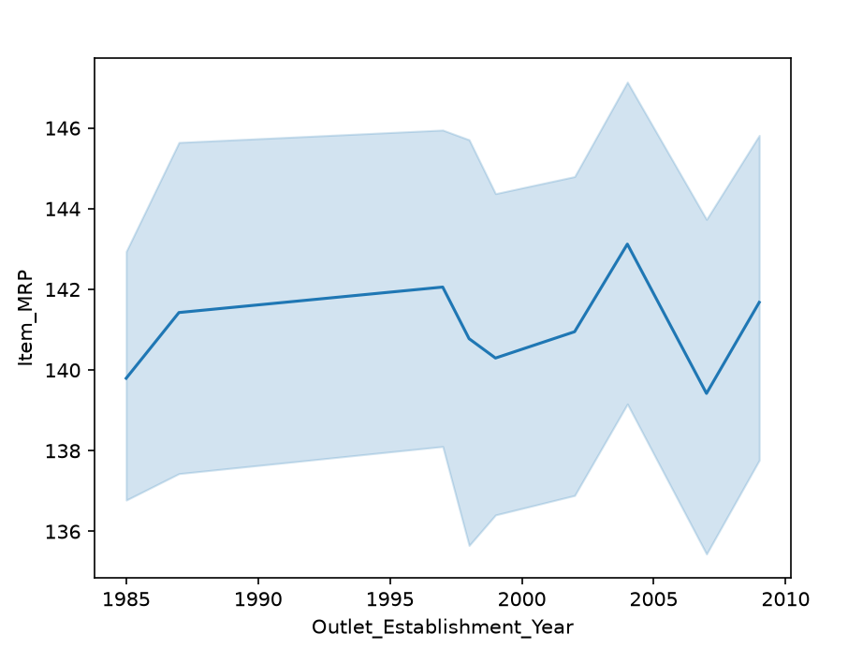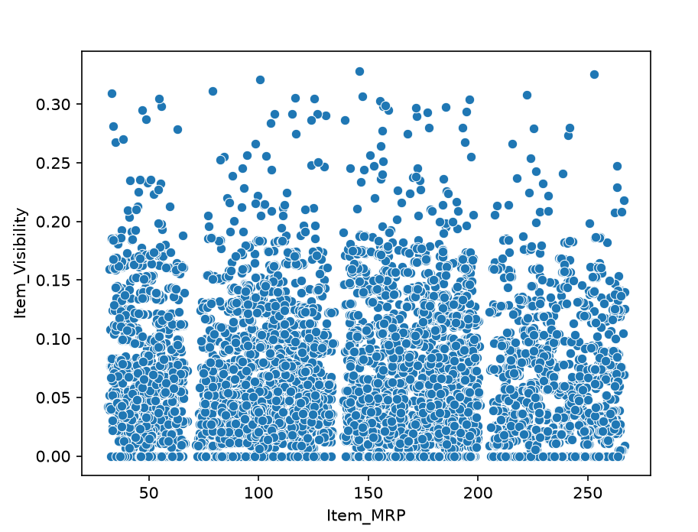
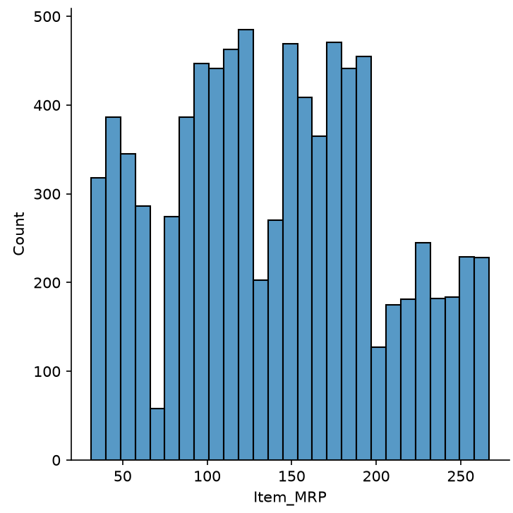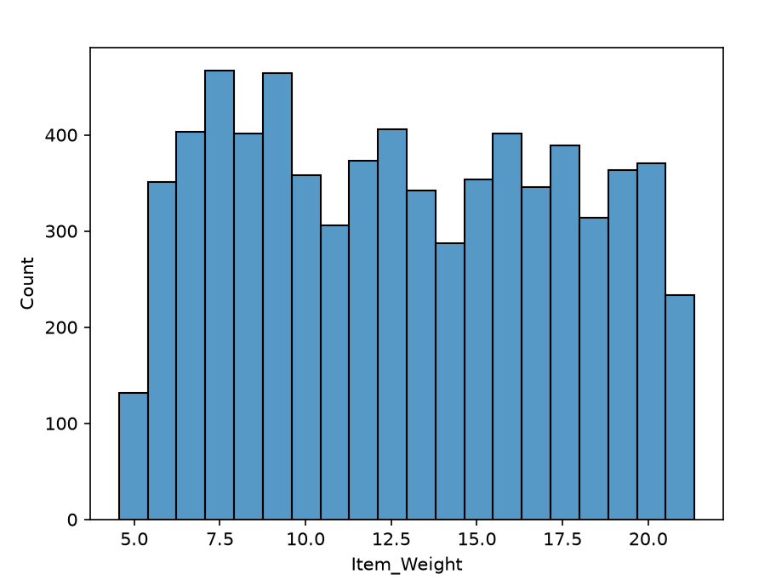
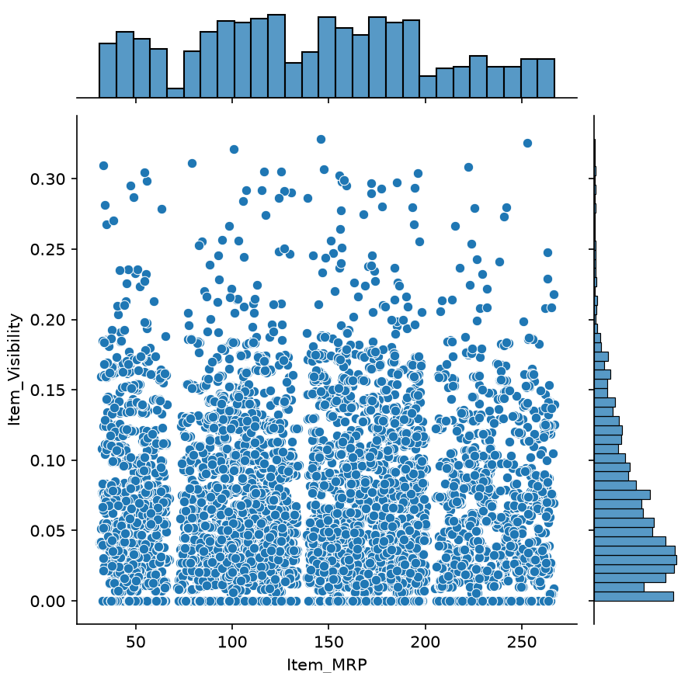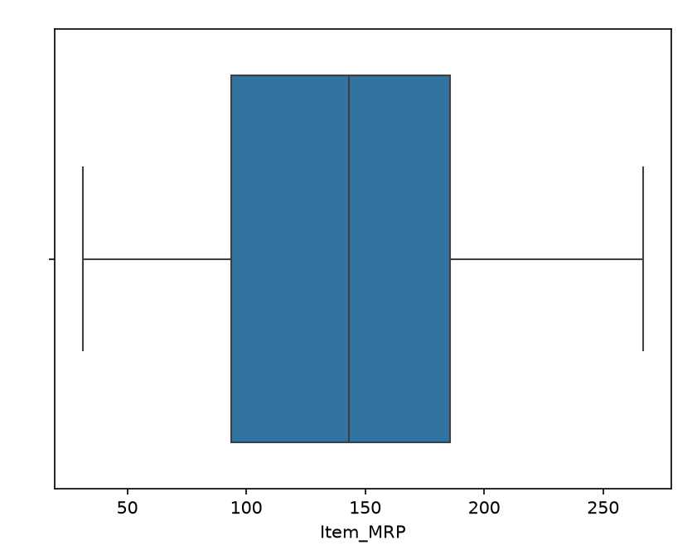

Test Dataset
import pandas as pd
import matplotlib.pyplot as plt
import seaborn as sns
# Read Test dataset
df = pd.read_csv("Week5/Test.csv")
# Display first 5 rows
print(df.head())
# 1. Line Plot
sns.lineplot(data=df, x="Outlet_Establishment_Year", y="Item_MRP")
plt.show()
# 2. Scatter Plot
sns.scatterplot(data=df, x="Item_MRP", y="Item_Visibility")
plt.show()
# 3. Displot
sns.displot(data=df, x="Item_MRP")
plt.show()
# 4. Histplot
sns.histplot(data=df, x="Item_Weight")
plt.show()
# 5. Joint Plot
sns.jointplot(data=df, x="Item_MRP", y="Item_Visibility")
plt.show()
# 6. Box Plot
sns.boxplot(x=df["Item_MRP"])
plt.show()
